**Control Structures**

**CODE :**

CREATE DATABASE BankSystem;

USE BankSystem;

-- Customers Table

CREATE TABLE Customers (

CustomerID INT PRIMARY KEY,

Name VARCHAR(100),

Age INT,

Balance DECIMAL(10,2),

InterestRate DECIMAL(5,2),

IsVIP VARCHAR(5)

);

-- Loans Table

CREATE TABLE Loans (

LoanID INT PRIMARY KEY,

CustomerID INT,

DueDate DATE,

FOREIGN KEY (CustomerID) REFERENCES Customers(CustomerID)

);

-- Sample Customers

INSERT INTO Customers VALUES

(101, 'Alice', 65, 8000.00, 7.5, 'FALSE'),

(102, 'Bob', 59, 12000.00, 6.9, 'FALSE'),

(103, 'Charlie', 70, 9500.00, 8.1, 'FALSE'),

(104, 'David', 45, 15000.00, 7.2, 'FALSE');

-- Sample Loans

INSERT INTO Loans VALUES

(201, 101, CURDATE() + INTERVAL 10 DAY),

(202, 102, CURDATE() + INTERVAL 40 DAY),

(203, 103, CURDATE() + INTERVAL 5 DAY);

UPDATE Customers

SET InterestRate = InterestRate - 1

WHERE Age > 60;

SELECT * FROM Customers;

SELECT * FROM loans;

UPDATE Customers

SET IsVIP = 'TRUE'

WHERE Balance > 10000;

SELECT * FROM Customers;

SELECT c.CustomerID, c.Name, l.LoanID, l.DueDate

FROM Loans l

JOIN Customers c ON c.CustomerID = l.CustomerID

WHERE l.DueDate <= CURDATE() + INTERVAL 30 DAY;

**OUTPUT :**

SCENARIO - 1:

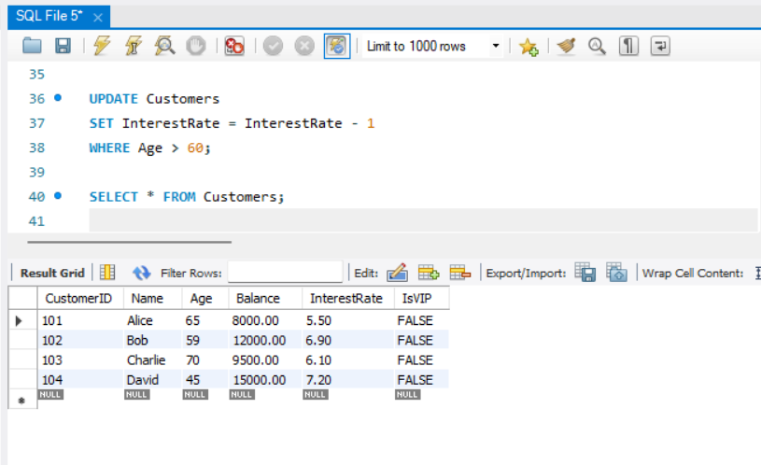

SCENARIO - 2 :

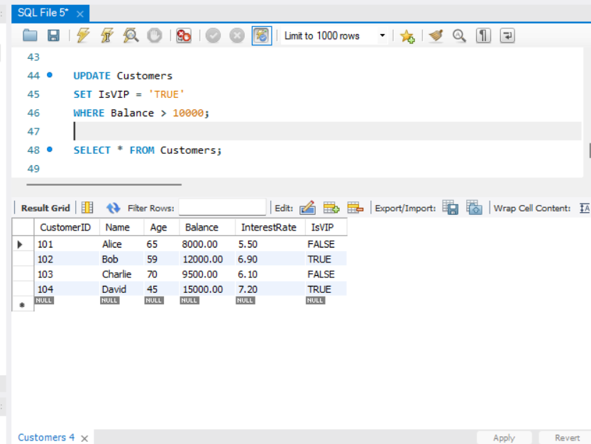

SCENARIO - 3 :

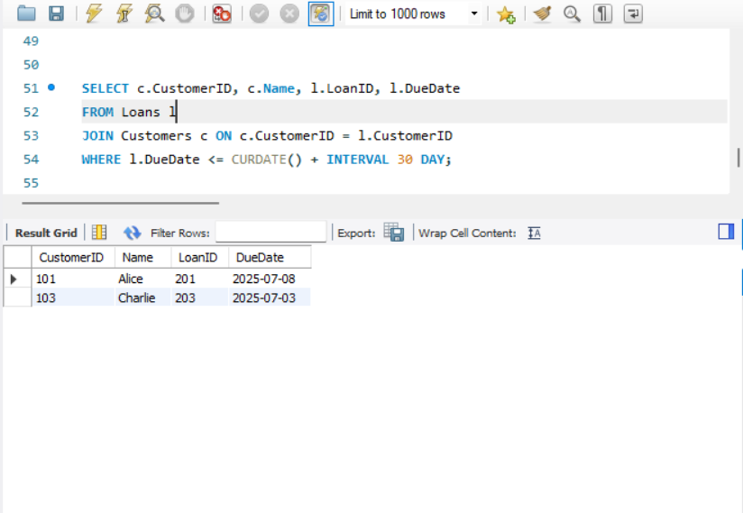

CUSTOMER TABLE :

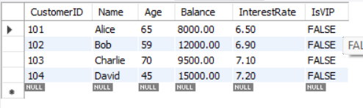

LOANS TABLE :

